Dear EA “Maxis” team:

The PokerGame application is a windows console application, so you can run from Command Prompt.

The application was created in C# .net 4.5 Visual Studio 2022.

To Execute or test, Unzip the attached file “**publish.zip**”.

The project will be in folder publish where you unzip it as sample "C:\Test"

Then open command prompt and change to directory

C:\Test\publish

Now you can run from here PokerGame.exe or run all test cases by running the script “**TestCases.bat**” in Command Prompt

You can run manually new test cases like

**PokerGame "2C, 2S, 3S, 3D, 4D | AH, AC, KS, QS, JD"**

Result:

***Poker Game! Params [2C, 2S, 3S, 3D, 4D | AH, AC, KS, QS, JD]***

***Hand 1 Results Two Pairs [10] [4]***

***Hand 2 Results One Pair [28] [13]***

***Hand 1 wins***!

This application recognizes the next rules for poker game where the better hand is “Straight flush” and the lower hand “High Card”

|  |  |
| --- | --- |
| 2 [Straight flush](https://en.wikipedia.org/wiki/List_of_poker_hands#Straight_flush)** | [Jack of clubs](https://en.wikipedia.org/wiki/File:Playing_card_club_J.svg)[10 of clubs](https://en.wikipedia.org/wiki/File:Playing_card_club_10.svg)[9 of clubs](https://en.wikipedia.org/wiki/File:Playing_card_club_9.svg)[8 of clubs](https://en.wikipedia.org/wiki/File:Playing_card_club_8.svg)[7 of clubs](https://en.wikipedia.org/wiki/File:Playing_card_club_7.svg) |
| 3 [Four of a kind](https://en.wikipedia.org/wiki/List_of_poker_hands#Four_of_a_kind) | [5 of clubs](https://en.wikipedia.org/wiki/File:Playing_card_club_5.svg)[5 of diamonds](https://en.wikipedia.org/wiki/File:Playing_card_diamond_5.svg)[5 of hearts](https://en.wikipedia.org/wiki/File:Playing_card_heart_5.svg)[5 of spades](https://en.wikipedia.org/wiki/File:Playing_card_spade_5.svg)[2 of diamonds](https://en.wikipedia.org/wiki/File:Playing_card_diamond_2.svg) |
| 4 [Full house](https://en.wikipedia.org/wiki/List_of_poker_hands#Full_house) | [6 of spades](https://en.wikipedia.org/wiki/File:Playing_card_spade_6.svg)[6 of hearts](https://en.wikipedia.org/wiki/File:Playing_card_heart_6.svg)[6 of diamonds](https://en.wikipedia.org/wiki/File:Playing_card_diamond_6.svg)[King of clubs](https://en.wikipedia.org/wiki/File:Playing_card_club_K.svg)[King of hearts](https://en.wikipedia.org/wiki/File:Playing_card_heart_K.svg) |
| 5 [Flush](https://en.wikipedia.org/wiki/List_of_poker_hands#Flush)** | [Jack of diamonds](https://en.wikipedia.org/wiki/File:Playing_card_diamond_J.svg)[9 of diamonds](https://en.wikipedia.org/wiki/File:Playing_card_diamond_9.svg)[8 of diamonds](https://en.wikipedia.org/wiki/File:Playing_card_diamond_8.svg)[4 of diamonds](https://en.wikipedia.org/wiki/File:Playing_card_diamond_4.svg)[3 of diamonds](https://en.wikipedia.org/wiki/File:Playing_card_diamond_3.svg) |
| 6 [Straight](https://en.wikipedia.org/wiki/List_of_poker_hands#Straight)** | [10 of diamonds](https://en.wikipedia.org/wiki/File:Playing_card_diamond_10.svg)[9 of spades](https://en.wikipedia.org/wiki/File:Playing_card_spade_9.svg)[8 of hearts](https://en.wikipedia.org/wiki/File:Playing_card_heart_8.svg)[7 of diamonds](https://en.wikipedia.org/wiki/File:Playing_card_diamond_7.svg)[6 of clubs](https://en.wikipedia.org/wiki/File:Playing_card_club_6.svg) |
| 7 [Three of a kind](https://en.wikipedia.org/wiki/List_of_poker_hands#Three_of_a_kind) | [Queen of clubs](https://en.wikipedia.org/wiki/File:Playing_card_club_Q.svg)[Queen of spades](https://en.wikipedia.org/wiki/File:Playing_card_spade_Q.svg)[Queen of hearts](https://en.wikipedia.org/wiki/File:Playing_card_heart_Q.svg)[9 of hearts](https://en.wikipedia.org/wiki/File:Playing_card_heart_9.svg)[2 of spades](https://en.wikipedia.org/wiki/File:Playing_card_spade_2.svg) |
| 8 [Two pair](https://en.wikipedia.org/wiki/List_of_poker_hands#Two_pair) | [Jack of hearts](https://en.wikipedia.org/wiki/File:Playing_card_heart_J.svg)[Jack of spades](https://en.wikipedia.org/wiki/File:Playing_card_spade_J.svg)[3 of clubs](https://en.wikipedia.org/wiki/File:Playing_card_club_3.svg)[3 of spades](https://en.wikipedia.org/wiki/File:Playing_card_spade_3.svg)[2 of hearts](https://en.wikipedia.org/wiki/File:Playing_card_heart_2.svg) |
| 9 [One pair](https://en.wikipedia.org/wiki/List_of_poker_hands#One_pair) | [10 of spades](https://en.wikipedia.org/wiki/File:Playing_card_spade_10.svg)[10 of hearts](https://en.wikipedia.org/wiki/File:Playing_card_heart_10.svg)[8 of spades](https://en.wikipedia.org/wiki/File:Playing_card_spade_8.svg)[7 of hearts](https://en.wikipedia.org/wiki/File:Playing_card_heart_7.svg)[4 of clubs](https://en.wikipedia.org/wiki/File:Playing_card_club_4.svg) |
| 10 [High card](https://en.wikipedia.org/wiki/List_of_poker_hands#High_card) | [King of diamonds](https://en.wikipedia.org/wiki/File:Playing_card_diamond_K.svg)[Queen of diamonds](https://en.wikipedia.org/wiki/File:Playing_card_diamond_Q.svg)[7 of spades](https://en.wikipedia.org/wiki/File:Playing_card_spade_7.svg)[4 of spades](https://en.wikipedia.org/wiki/File:Playing_card_spade_4.svg)[3 of hearts](https://en.wikipedia.org/wiki/File:Playing_card_heart_3.svg) |

I created more than 20 “Unit Test” using MS Test project “**TestPoker.UnitTest**” here is a screen shot:

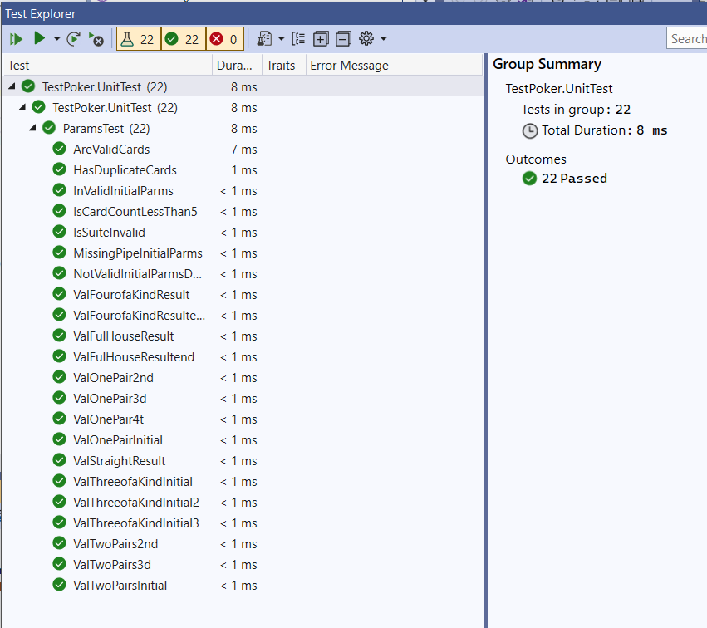

and 13 “Functional Test” in “**TestCases.bat**” attached my results in “results.txt” file.

Please let me know if you have any questions.

Ismael Jimenez.